Mathinator
Software Architecture Document

Version <1.1>

Revision History
Date | Version | Description | Author
<28/11/2016> | <1.0> | <Creation of the SAD> | <Lamm, Hug, Saupp>
<27/12/2016> | <1.1> | <Adapt the Technology + Database Diagram> | <Lamm, Hug, Saupp>

Table of Contents
1. Introduction 4
1.1 Purpose 4
1.2 Scope 4
1.3 Definitions, Acronyms, and Abbreviations 4
1.4 References 4
1.5 Overview 4
2. Architectural Representation 5
3. Architectural Goals and Constraints 5
4. Use-Case View 5
5. Logical View 6
6. Process View 6
7. Deployment View 6
8. Implementation View 6
9. Data View (optional) 6
10. Size and Performance 6
11. Quality 6
Software Architecture Document
- Introduction

  - Purpose
This document provides a comprehensive architectural overview of the system, using a number of different architectural views to depict different aspects of the system. It is intended to capture and convey the significant architectural decisions which have been made on the system.

  - Scope
The scope of this SAD is to provide the architecture of the Mathinator project. Affected are the class structure, our use-cases and the
  - Definitions, Acronyms, and Abbreviations
  - References
Document | Where to find?
Blog | https://mathinator.tobiaslamm.de
Github | https://github.com/SaschaHug/Mathinator
Use Case 1 “take a picture” | https://github.com/SaschaHug/Mathinator/blob/master/1_UC_Mathinator_Take_A_Picture.pdf
Use Case 2 “view history” | https://github.com/SaschaHug/Mathinator/blob/master/2_UC_Mathinator_View_History.pdf
Use Case 3 “show tour on first start”
Use Case 4 “enable user to delete entries”
Use Case 5 “do manual calculations”

  - Overview
The rest of the document is separated into ten different chapters.
Chapter 2 will describe what software architecture is for the current system, and how is represented. Chapter 3 will cover the software requirements and objectives that have some significant impact on the architecture. Chapter 4 lists use cases/scenarios from the use-case model which have significant impact on the architecture itself. Chapter 5 describes the architecturally significant parts of the design model, such as its parts Controller and Model. Chapter 9 is a description of the persistent data storage perspective of the system.

- Architectural Representation
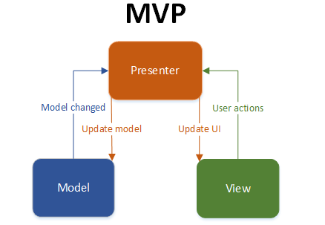
- Architectural Goals and Constraints
In Android you don't have MVC, but you have the following:
- You define your user interface in various XML files by resolution, hardware, etc.
- You define your resources in various XML files by locale, etc.
- You extend clases like ListActivity, TabActivity and make use of the XML file by inflaters.
- You can create as many classes as you wish for your business logic.
- A lot of Utils have been already written for you - DatabaseUtils, Html.

- Use-Case View
n/a

- Logical View

Description
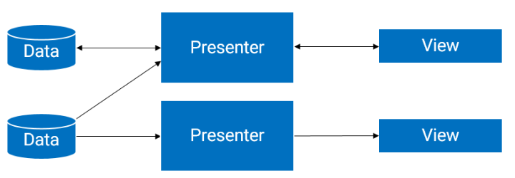
- Process View
n/a
- Deployment View
n/a
- Implementation View
n/a
- Data View (optional)
To be determined
- Size and Performance
n/a
- Quality
n/a

